Lab Exercise 1 - Recursive Queries with Recursive CTEs in PostgreSQL

1. Lab Overview
In this hands-on lab, you will learn how to use Recursive Common Table Expressions (Recursive CTEs) in PostgreSQL.
Recursive CTEs are useful when data has a hierarchical or tree-like relationship, such as:
- Employee → Manager
- Organization → Departments
- Category → Subcategory
- Folder → Subfolder
- Parent → Child records
- Organization charts
In this lab, we will use an employee-manager hierarchy.
Estimated Time
45–60 minutes
Prerequisites
- PostgreSQL installed
- psql or pgAdmin
- Basic knowledge of:
  - SELECT
  - WHERE
  - JOIN
  - INSERT

2. Learning Objectives
After completing this lab, you will be able to:
- Understand recursive CTEs.
- Understand the anchor query and recursive query.
- Traverse hierarchical data.
- Find all employees under a manager.
- Determine an employee's management hierarchy.
- Calculate hierarchy levels.
- Build an organization tree.
- Understand common problems with recursive queries.

3. What is a Recursive CTE?
A normal CTE looks like:
WITH employee_data AS (
SELECT *
FROM employees
)
SELECT *
FROM employee_data;
A recursive CTE repeatedly executes a query using the results of the previous execution.
The basic structure is:
WITH RECURSIVE cte_name AS (
-- Anchor query
SELECT ...
UNION ALL
-- Recursive query
SELECT ...
FROM table
JOIN cte_name ...
)
SELECT *
FROM cte_name;
The recursive CTE has two important parts:
Anchor Query
↓
Initial rows
↓
Recursive Query
↓
More rows
↓
Recursive Query
↓
More rows
↓
Stop when no more rows

4. Business Scenario
Suppose a company has the following organizational structure:
CEO
|
┌─────────┴─────────┐
| |
CTO CFO
|
┌────┴────┐
| |
Manager1 Manager2
| |
┌─┴─┐ ┌─┴─┐
Dev1 Dev2 Dev3 Dev4

The company wants to answer questions such as:
- Who reports directly to the CTO?
- Who reports indirectly to the CTO?
- How many levels exist below the CEO?
- What is the complete reporting hierarchy?
- Who is the manager of a particular employee?
- What is the path from an employee to the CEO?
These are ideal use cases for recursive CTEs.

5. Create the Database
Create a database:
CREATE DATABASE recursive_demo;
Connect to it:
\c recursive_demo
If you are using pgAdmin, create the database and open the Query Tool.

6. Create the Employees Table
Run:
CREATE TABLE employees (
employee_id INT PRIMARY KEY,
employee_name VARCHAR(100) NOT NULL,
manager_id INT,
department VARCHAR(50),
salary NUMERIC(10,2)
);
The important column is:
manager_id
It contains the employee_id of the employee's manager.
For example:
employee_id = 2
manager_id = 1
means:
Employee 2 reports to Employee 1.

7. Insert Sample Data
Run:
INSERT INTO employees
(employee_id, employee_name, manager_id, department, salary)
VALUES
(1, 'Rajesh', NULL, 'Executive', 150000),
(2, 'Amit', 1, 'Technology', 120000),
(3, 'Priya', 1, 'Finance', 115000),
(4, 'Rahul', 2, 'Technology', 90000),
(5, 'Sneha', 2, 'Technology', 85000),
(6, 'Vikas', 4, 'Technology', 70000),
(7, 'Neha', 4, 'Technology', 68000),
(8, 'Ankit', 5, 'Technology', 65000),
(9, 'Pooja', 3, 'Finance', 75000),
(10, 'Rohit', 3, 'Finance', 72000);

8. View the Data
Run:
SELECT *
FROM employees
ORDER BY employee_id;
You should see:
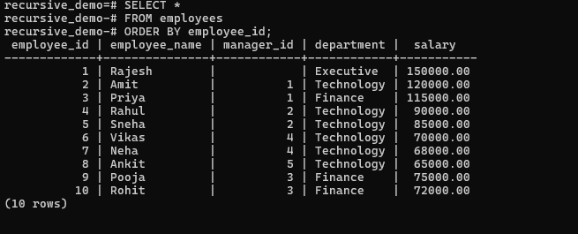
The hierarchy is:
Rajesh
├── Amit
│ ├── Rahul
│ │ ├── Vikas
│ │ └── Neha
│ └── Sneha
│ └── Ankit
│
└── Priya
├── Pooja
└── Rohit

9. Exercise 1 – Find Direct Reports
Before using recursion, find employees who directly report to Rajesh.
SELECT
employee_id,
employee_name,
manager_id
FROM employees
WHERE manager_id = 1;

Expected:
employee_id | employee_name
-------------+--------------
2 | Amit
3 | Priya
This only returns one level.
It does not return:
Rahul
Sneha
Vikas
Neha
Ankit
Pooja
Rohit
This is where recursive CTEs become useful.

10. Exercise 2 – Basic Recursive CTE
Now find all employees under Rajesh.
Run:
WITH RECURSIVE employee_hierarchy AS (

-- Anchor query
SELECT
employee_id,
employee_name,
manager_id,
0 AS level
FROM employees
WHERE employee_id = 1

UNION ALL

-- Recursive query
SELECT
e.employee_id,
e.employee_name,
e.manager_id,
eh.level + 1
FROM employees e
JOIN employee_hierarchy eh
ON e.manager_id = eh.employee_id
)

SELECT *
FROM employee_hierarchy
ORDER BY level, employee_id;
Expected result:
employee_id | employee_name | manager_id | level
------------+---------------+------------+------
1 | Rajesh | NULL | 0
2 | Amit | 1 | 1
3 | Priya | 1 | 1
4 | Rahul | 2 | 2
5 | Sneha | 2 | 2
9 | Pooja | 3 | 2
10 | Rohit | 3 | 2
6 | Vikas | 4 | 3
7 | Neha | 4 | 3
8 | Ankit | 5 | 3
11. Understand the Recursive Query
The query has two sections.
Anchor Query
SELECT
employee_id,
employee_name,
manager_id,
0 AS level
FROM employees
WHERE employee_id = 1
This starts with:
Rajesh
So:
level = 0

Recursive Query
SELECT
e.employee_id,
e.employee_name,
e.manager_id,
eh.level + 1
FROM employees e
JOIN employee_hierarchy eh
ON e.manager_id = eh.employee_id
It finds employees whose:
manager_id
matches the employee from the previous level.

The process becomes:
Level 0
Rajesh

↓

Level 1
Amit
Priya

↓

Level 2
Rahul
Sneha
Pooja
Rohit

↓

Level 3
Vikas
Neha
Ankit

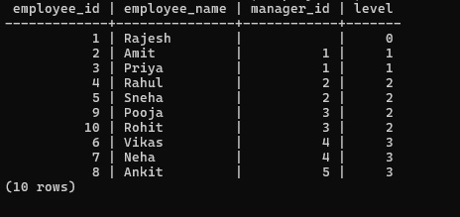

12. Exercise 3 – Display the Hierarchy as a Tree
We can create a visual hierarchy using indentation.
WITH RECURSIVE employee_hierarchy AS (
SELECT
employee_id,
employee_name,
manager_id,
0 AS level
FROM employees
WHERE manager_id IS NULL

UNION ALL
SELECT
e.employee_id,
e.employee_name,
e.manager_id,
eh.level + 1
FROM employees e
JOIN employee_hierarchy eh
ON e.manager_id = eh.employee_id
)
SELECT
repeat(' ', level) ||
employee_name AS organization_tree
FROM employee_hierarchy
ORDER BY level, employee_id;
The output will look approximately like:
Rajesh
Amit
Priya
Rahul
Sneha
Pooja
Rohit
Vikas
Neha
Ankit
The repeat() function generates spaces for each hierarchy level.
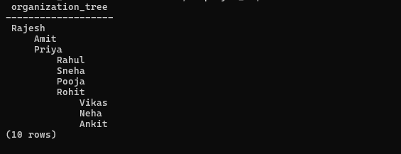

13. Exercise 4 – Find Everyone Reporting to Amit
Now suppose Amit wants to know everyone who works under him.
Use:
WITH RECURSIVE employee_hierarchy AS (

SELECT
employee_id,
employee_name,
manager_id,
0 AS level
FROM employees
WHERE employee_id = 2

UNION ALL

SELECT
e.employee_id,
e.employee_name,
e.manager_id,
eh.level + 1
FROM employees e
JOIN employee_hierarchy eh
ON e.manager_id = eh.employee_id
)

SELECT *
FROM employee_hierarchy;

Expected:
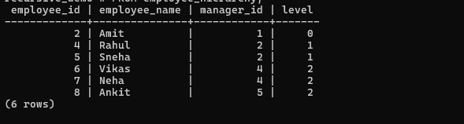

Amit
Rahul
Sneha
Vikas
Neha
Ankit
This includes both direct and indirect reports.

14. Exercise 5 – Find the Management Chain
Now we will solve the opposite problem.
Suppose we want to find the management chain for Vikas.
The hierarchy is:
Rajesh
↓
Amit
↓
Rahul
↓
Vikas
Run:
WITH RECURSIVE management_chain AS (
SELECT
employee_id,
employee_name,
manager_id,
0 AS level
FROM employees
WHERE employee_id = 6
UNION ALL
SELECT
e.employee_id,
e.employee_name,
e.manager_id,
mc.level + 1
FROM employees e
JOIN management_chain mc
ON mc.manager_id = e.employee_id
)
SELECT *
FROM management_chain;
Expected:
employee_name | level
--------------+------
Vikas | 0
Rahul | 1
Amit | 2
Rajesh | 3

15. Exercise 6 – Generate a Management Path
We can create a complete path.
WITH RECURSIVE management_chain AS (

SELECT
employee_id,
employee_name,
manager_id,
employee_name::TEXT AS path
FROM employees
WHERE employee_id = 6

UNION ALL

SELECT
e.employee_id,
e.employee_name,
e.manager_id,
mc.path || ' -> ' || e.employee_name
FROM employees e
JOIN management_chain mc
ON mc.manager_id = e.employee_id
)

SELECT *
FROM management_chain
ORDER BY employee_id;
You will get paths such as:
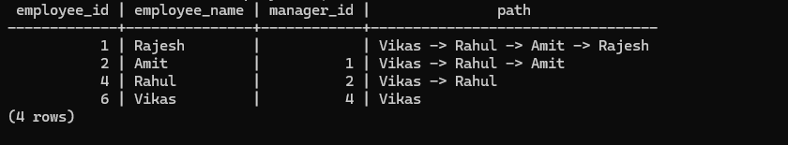
Vikas
Vikas -> Rahul
Vikas -> Rahul -> Amit
Vikas -> Rahul -> Amit -> Rajesh

16. Exercise 7 – Find the Number of Levels
How many levels exist below the CEO?
WITH RECURSIVE employee_hierarchy AS (
SELECT
employee_id,
employee_name,
manager_id,
0 AS level
FROM employees
WHERE manager_id IS NULL
UNION ALL
SELECT
e.employee_id,
e.employee_name,
e.manager_id,
eh.level + 1
FROM employees e
JOIN employee_hierarchy eh
ON e.manager_id = eh.employee_id
)
SELECT MAX(level) AS maximum_hierarchy_level
FROM employee_hierarchy;
Expected:
maximum_hierarchy_level
------------------------
3

17. Exercise 8 – Count Employees at Each Level
WITH RECURSIVE employee_hierarchy AS (
SELECT
employee_id,
employee_name,
manager_id,
0 AS level
FROM employees
WHERE manager_id IS NULL
UNION ALL
SELECT
e.employee_id,
e.employee_name,
e.manager_id,
eh.level + 1
FROM employees e
JOIN employee_hierarchy eh
ON e.manager_id = eh.employee_id
)
SELECT
level,
COUNT(*) AS employee_count
FROM employee_hierarchy
GROUP BY level
ORDER BY level;
Expected:
level | employee_count
------+---------------
0 | 1
1 | 2
2 | 4
3 | 3

18. Exercise 9 – Find Leaf Employees
Leaf employees are employees who have no employees reporting to them.
Run:
SELECT
e.employee_id,
e.employee_name
FROM employees e
WHERE NOT EXISTS (
SELECT 1
FROM employees child
WHERE child.manager_id = e.employee_id
);
Expected:
Vikas
Neha
Ankit
Pooja
Rohit

